

**Semester Two Examination 2017**

**Question/Answer Booklet**

**MATHEMATICS**

**METHODS UNITS 3 & 4**

**Section One:**

**Calculator–free**

|  |
| --- |
| Student Name: _____________________________________ |
| Teacher‘s Name: _____________________________________ |
|  |

**Time allowed for this section**

Reading time before commencing work: five minutes

Working time for paper: fifty minutes

**Material required/recommended for this section**

**To be provided by the supervisor**

This Question/Answer booklet

Formula Sheet

**To be provided by the candidate**

Standard items: pens(blue/black preferred), pencils(including coloured), sharpener, correction tape/fluid, erasers, ruler, highlighters

Special Items: nil

**Important note to candidates**

No other items may be taken into the examination room. It is **your** responsibility to ensure that you do not have any unauthorised notes or other items of a non–personal nature in the examination room. If you have any unauthorised material with you, hand it to the supervisor **before** reading any further.

**Structure of this paper**

|  |  |  |  |  |  |
| --- | --- | --- | --- | --- | --- |
|  | Number of questions available | Number of questions to be attempted | Working time (minutes) | Marks available | Percentage of exam |
| **Section One**  **Calculator—free** | **8** | **8** | **50** | **50** | **35** |
| Section Two  Calculator—assumed | 12 | 12 | 100 | 98 | 65 |
|  | | | |  | 100 |

**Instructions to candidates**

1. The rules for the conduct of Western Australian external examinations are detailed in the *Year 12 Information Handbook 2017.* Sitting this examination implies that you agree to abide by these rules.
2. Answer the questions according to the following instructions.

Section One: Write answers in this Question/Answer Booklet. Answer **all** questions.

**Show all your working clearly.** Your working should be in sufficient detail to allow your

answers to be checked readily and for marks to be awarded for reasoning. Incorrect

answers given without supporting reasoning cannot be allocated any marks. For any

question or part question worth more than two marks, valid working or justification is

required to receive full marks. If you repeat an answer to any question, ensure that you

cancel the answer you do not wish to have marked.

It is recommended that you **do not use pencil**, except in diagrams.

1. You must be careful to confine your responses to the specific questions asked and to follow any instructions that are specific to a particular question.
2. Spare pages are included at the end of this booklet. They can be used for planning your responses and/or as additional space if required to continue an answer.

* Planning: If you use the spare pages for planning, indicate this clearly at the top of the

page.

* Continuing an answer: If you need to use the space to continue an answer, indicate in the original answer space where the answer is continued, i.e. give the page number. Fill in the number of the question that you are continuing to answer at the top of the page.

1. The Formula Sheet is **not** handed in with your Question/Answer Booklet.

# Section One: Calculator–free 50 marks

This section has **eight (8)** questions. Attempt **all** questions. Write your answers in the spaces provided.

Spare pages are included at the end of this booklet. They can be used for planning your responses and/or as additional space if required to continue an answer.

* Planning: If you use the spare pages for planning, indicate this clearly at the top of the page.
* Continuing an answer: If you need to use the space to continue an answer, indicate in the original answer space where the answer is continued, i.e. give the page number. Fill in the number of the question(s) that you are continuing to answer at the top of the page.

Working time: 50 minutes

**Question 1 (4 marks)**

(a) Determine the following derivative.

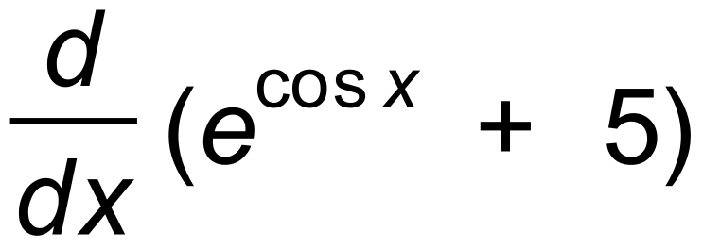 (2 marks)

(b) Hence determine the following integral.

(2 marks)

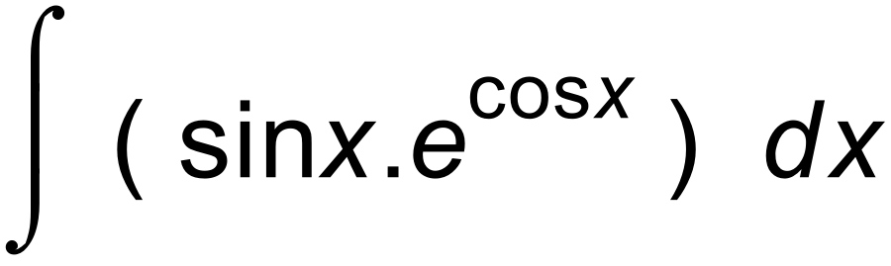

**Question 2 (5 marks)**

Consider the function f (x) = e2x – ln x , where x > 0.

(a) Show that there exists a stationary point where x = 0.5 e –2x (3 marks)

It can be shown that f ′′(x) = 4e2x + 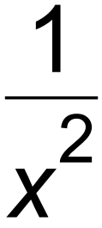

(b) Determine the nature of the stationary point determined in (a). (2 marks)

**Question 3 (5 marks)**

Consider the graphs of y = x and y = 2 – e–x

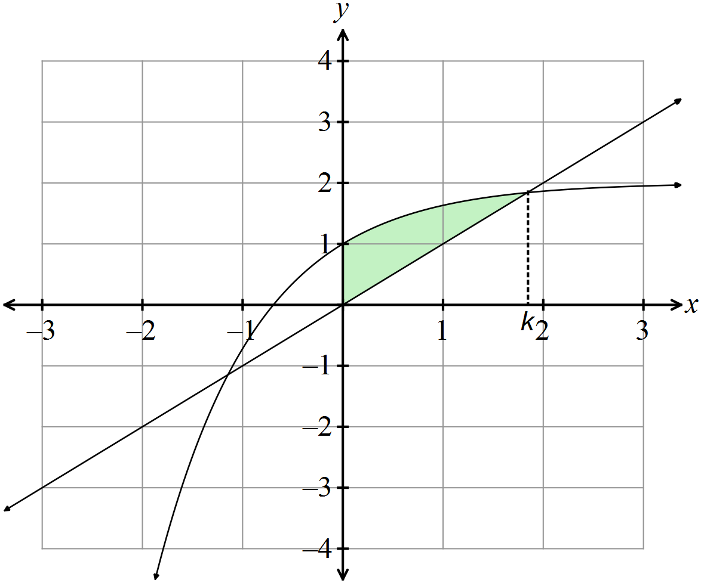

(a) Write an integral which is equal to the area shaded in the diagram above. (2 marks)

(b) Determine the area in terms of k. (3 marks)

**Question 4 (7 marks)**

Determine the following, giving your answers in exact form.

(a) 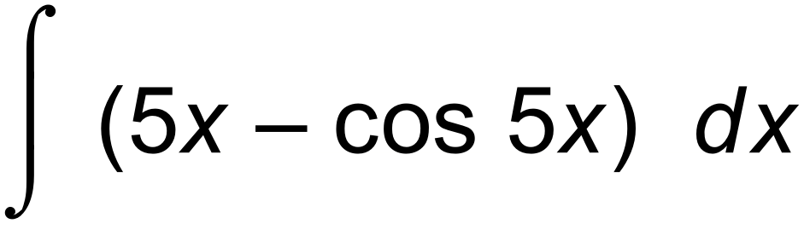 (2 marks)

(b) 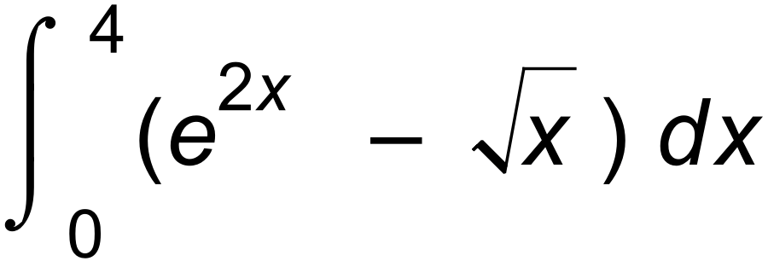 (3 marks)

(c) 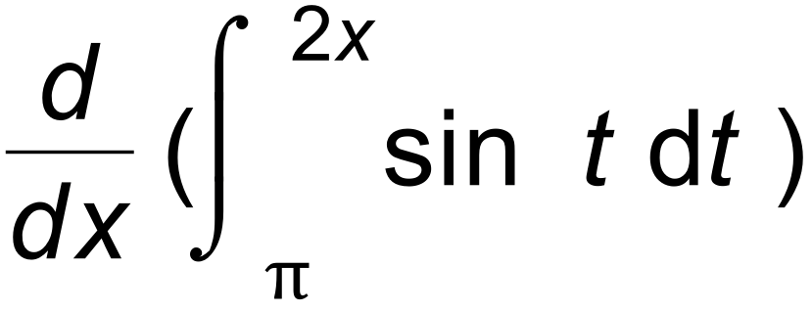 (2 marks)

**Question 5 (7 marks)**

The velocity (v) of a body at time t seconds travelling along a linear path is given by the rule

v = 2cos 2t – 2e -2t

(a) Determine the displacement of the body, given that the body is initially

1 unit to the right of the origin. (3 marks)

(b) Determine the acceleration of the body at any time t. (2 marks)

(c) Show that the relationship between displacement and acceleration

is NOT of the form a =– k2 x .

(2 marks)

**Question 6 (7 marks)**

(a) Evaluate log ( 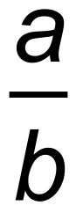 ) + log( 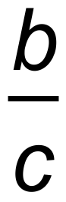 ) + log(  ) . (2 marks)

(b) Solve these simultaneous equations and show that x = 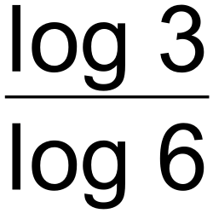 .

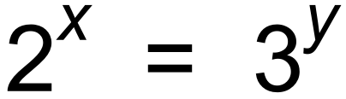 and x + y = 1 (5 marks)

**Question 7 (8 marks)**

Consider the graph of y = f (x) shown below.

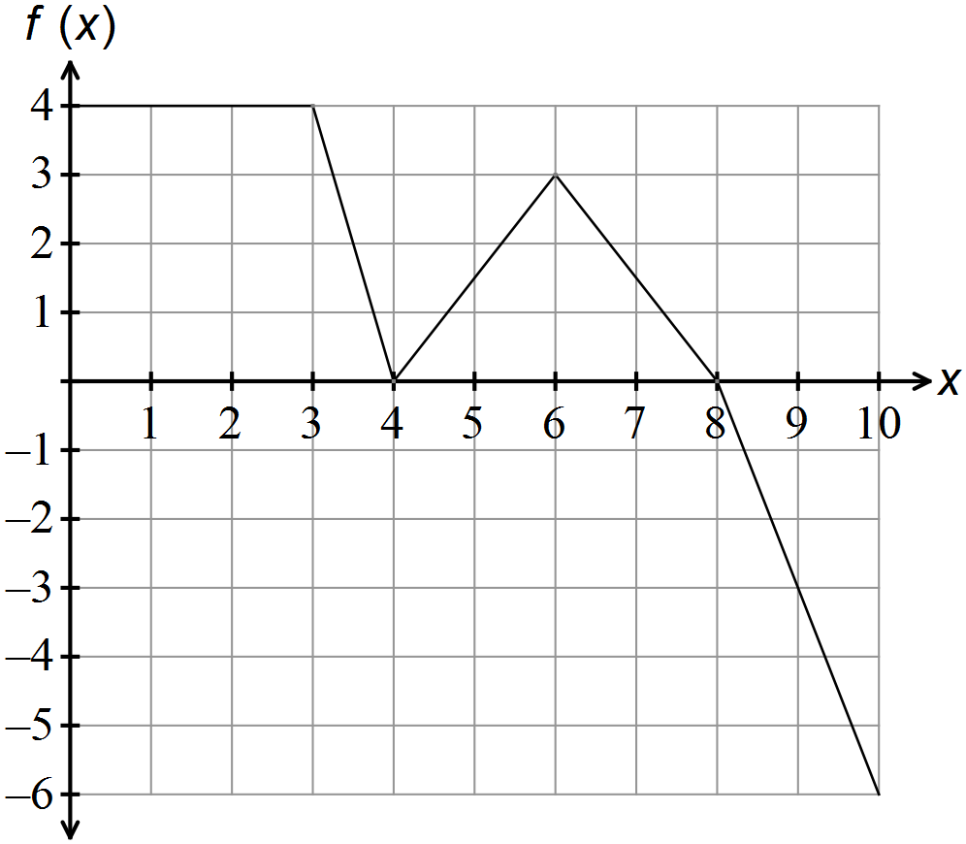



(a) Determine the value of:

(i) 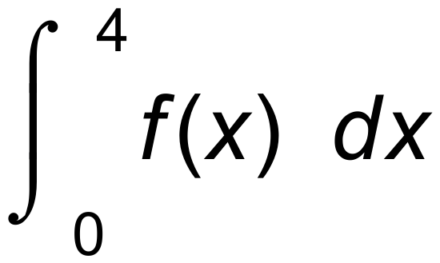 (1 mark)

(ii) 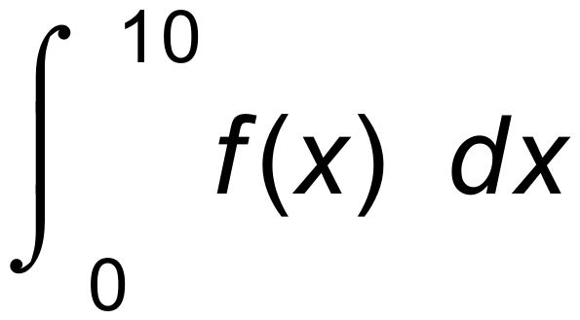 (2 marks)

(iii) 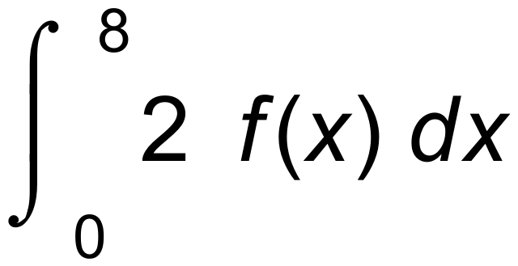 (2 marks)

(b) Find integers *a*, *b* and *c*, where *a* ≠ *c*, if 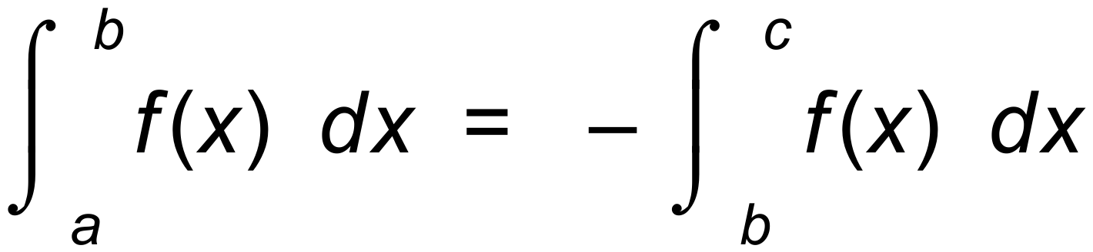 (3 marks)

**Question 8 (7 marks)**

The first quadrant of y = 3cos 2x is shown.

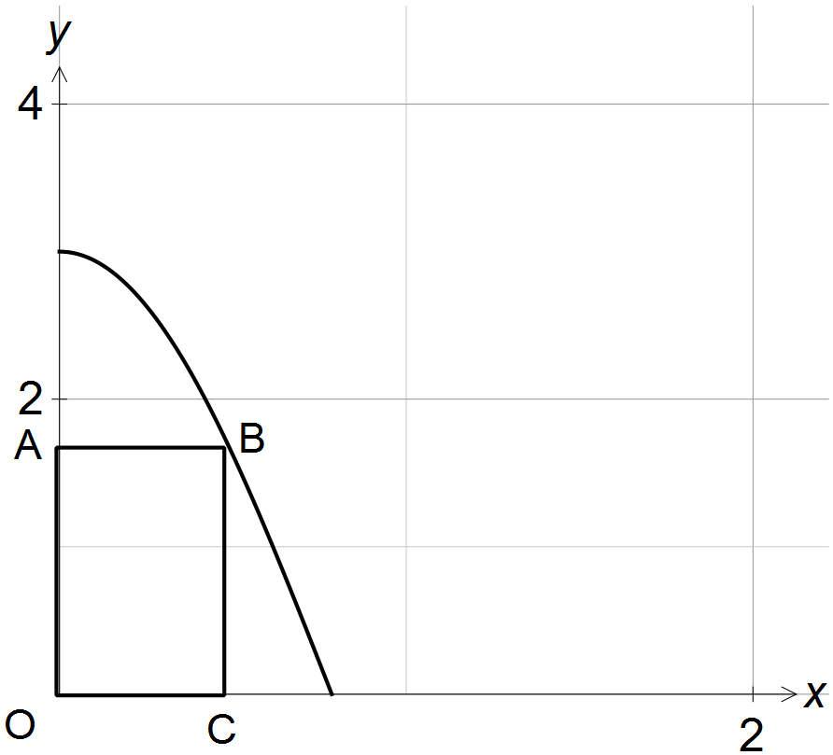

(a) Show that the area of rectangle OABC = 3x.cos 2x. (1 mark)

(b) Show that for the area of OABC to be a maximum, 2x.tan 2x – 1 = 0. (3 marks)

(c) Given the result from (b), use the second derivative to show that sin 2x + x cos 2x > 0. (3 marks)

**End of Section One**

**Additional working space**

Question number(s): ……………………